

**Note Taking Application**

**Code Refactoring and Bug Fixing**

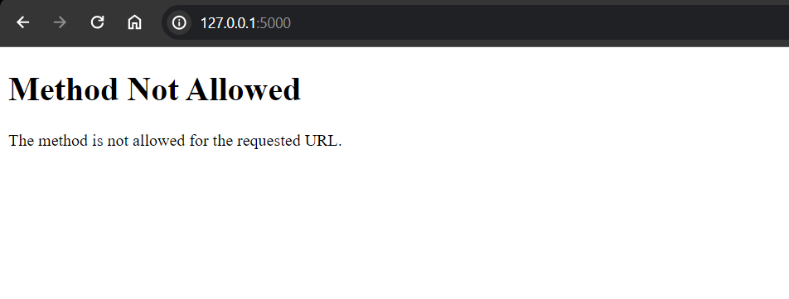

I have executed using command : python app.py

The "405 Method Not Allowed" error indicates that the server received a request with a method that is not allowed for the specified route.

from flask import Flask, render_template, request

app = Flask(__name__)

notes = []

@app.route('/', methods=["POST"])

def index():

    note = request.args.get("note")

    notes.append(note)

    return render_template("home.html", notes=notes)

if __name__ == '__main__':

    app.run(debug=True)

The error we are getting because we have used **request.args.get("note")**, but since we are using the POST method in your form, so we have to use **request.form.get("note")** instead.

This change ensures that you correctly retrieve the value of the "note" input from the form when handling a POST request. Now, when you submit the form, the entered note should be added to the **notes** list, and the updated list will be passed to the template for rendering.

 <form action="" method="post">

        <input type="text" name="note" placeholder="Enter a note">

        <button>Add Note</button>

    </form>

In the home.html code I just added the **method=”post”** in the form tag to explicitly specify that the form should use the POST method when submitting data.

@app.route('/', methods=["POST"])

def index():

    note = request.form.get("note")

    notes.append(note)

    return render_template("home.html", notes=notes)

In the above route part we can easily observe that our index method is designed only to handle the POST requests This means that the **index** function can only handle POST requests. When we access the root path in your browser, it sends a GET request by default, resulting in the "405 Method Not Allowed" error.

To solve the issue I have updated our route to handle both GET and POST requests

@app.route('/', methods=["GET","POST"])

def index():

    if request.method == "POST":

        note = request.form.get("note")

        notes.append(note)

    return render_template("home.html", notes=notes)

With this modification, the route can handle both GET and POST requests. When you access the root path via a web browser, it will render the HTML page. When you submit the form, it will send a POST request, and the form data will be processed by the **index** function.

Additionally I have added css styles in HTML within <style></style>

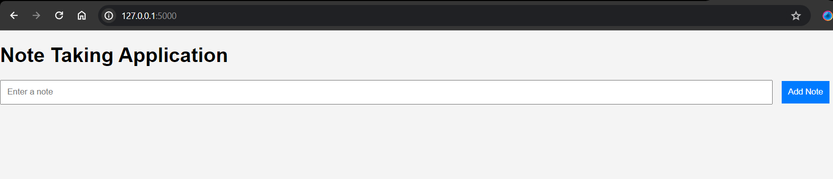

This is the home page we get and we can add note in the box and once we click on Add Note button the text we entered will be able to visible in the same page below the page. Example, I have entered the text and submitted which I can able to view below.

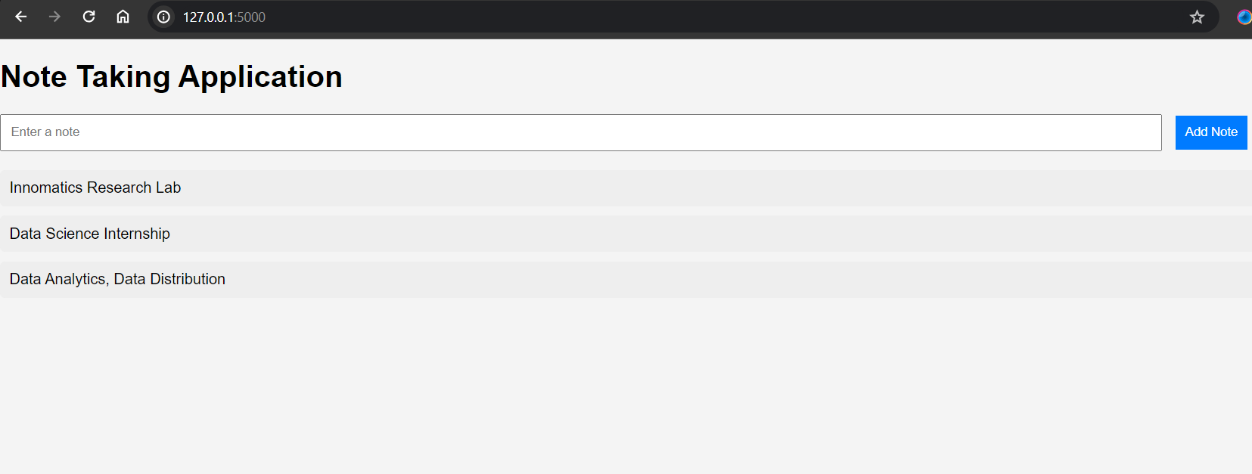

This is the final home page after adding the note.